Design Sites Assessment Task 2: Design Report
  - By Chris Craig

Scenario: Larry’s Lawns

Introduction
Larry’s Lawns is a small business but growing. It began as a family owned and operated lawn mowing service. While still operating the local, family business, Larry’s Lawns has begun franchising and wishes to expand both aspects of their business.

Goals for the web site
- Attract customers to the lawn mowing business
- Provide a corporate identity for the enterprise
- Attract potential franchisees
- Capture interest – demonstrated by return visits

Target Audience

Primary
- Home owners
- Renters
- Age group – 18 to 100 year old; extremely broad
- People who are time poor and want their lawn maintained
- People who are unable to maintain their lawns themselves

Secondary
- Potential franchisees
- 20 – 55 year old people
- Interested in self employment

Requirements
- Useful content
- Attractive homepage
- A calendar to display upcoming events
- A section able to be updated by Larry’s Lawns
- A banner/log image
- Other images
- A jQuery element
- CSS3 elements
- HTML & CSS standards compliant
- Compliant with Accessibility standard
- Be accessible on small screens including phones and tablets

Research

Site 1 – Jim’s Lawn Mowing
http://www.jimsmowing.net/
Jim’s Mowing is the market leader in this field. Their web site is in some ways basic – black text on a white background with their colour scheme restricted to headings and navigation bars. The suite does feature animation and audio, however.
Vision and sound are delivered via Adobe Flash, therefore limiting their browser compatibility.
Images are displayed using a jQuery slider. The site is responsive and the elements stack at breakpoints as the window is resized. A plain but functional site – with a dash of flash added, literally.

Site 2 – Hire A Hubby
http://www.hireahubby.com.au/
While not a lawn mowing business, Hire A Hubby is a company with a similar business model and target audience to Larry’s Lawns.
Again, it is a relatively plain web site, black text on a white background dominated by a huge image slider. The image slider is impressively incorporated into the javaScript driven “mega menu” (that’s actually the name of the element in the page’s code).
With the huge image slider and blog like layout of content, the site has the smell of WordPress about it – a suspicion confirmed by a scan of the code.
Strangely, for a WordPress template, the site is not in the least responsive. The layout does not react at all to a change in window size – leaving only a small portion of the page visible.
It also breaks the cardinal rule of having a significant amount of content below the fold on the home page. Also, every item has a solid paragraph of text followed by a “read more” tag. The full page-width slider notwithstanding, this site is text heavy and probably experiences a high bounce rate. Research show that people on average read less than 20% of text on a web page. A web site needs to grab the visitor’s attention and keep it – this site doesn’t.

Site 3 – getoffmylawn.com
http://getoffofmylawn.com/pages/home
Despite the mention of lawn in the URL, this site has absolutely nothing to do mowing lawns! It is actually the web site of an American cover band called “Geezers.”
Geezers are a band who play rock and roll, as they say, the way it should be played: “by senior citizens!”
There is nothing WordPress about this site. It is a bespoke web site that has been built by smart people.
The homepage, while extending below the fold, is mainly text free. Vision and sound are supplied by a link to You Tube in an HTML5 iframe – ensuring universal browser compatibility (as opposed to Flash, for example).
This site demonstrates the value of a sense of humour on the internet – it uses gags to catch the interest of the visitor and provide layers of interest to keep them coming back.
For example, click on the Tumblr icon at the top of the page and see what happens.
They also use novel code to encourage readers to wade through large slabs of text. On the “History” page, they use CSS animation to blur the content – simulating the degeneration of a geezer’s eyesight. Then they invite the visitor to “use their electric computing machine” to experience “Geezer Vision.” jQuery is used to set up a magnifying glass on hover and the text is enlarged and cleared. It’s absolutely cool and worth a look on http://getoffofmylawn.com/pages/history.
That is not to say that Larry’s Lawns web site should turn into a slapstick comedy festival. But getoffmylawn.com is a great example of how audio, vision, animation, color and movement, and yes, even a touch of humour, can be used to create interest, visits and business.
It has worked for Geezers. From the video on their page, they are not a very good band. But if they came to town I’d queue up to see them – because their web site is so cool!

Site Map

Services
mowing.html
Advice
lawns.html
About Us
about.html
Quotes
contact.html
Franchising
frachise.html
Find Us locate a franchisee findus.html
Home Page
Index.html

Events
calendar.html

Draft Style Guide
The pages on this site will be constructed to display on a screen 1024px x 768px as it is understood this is the screen resolution used by the client. They will also be responsive, however, as per the requirements, and able to be viewed on a range of devices.
The fonts and colour will obviously be different for each prototype. They are listed separately below:
Main Headings: Green, green grass: h1(bold by default), Verdana, #ffeb09;
Dark side of the moon: h1, OCR A std, #00ff00;
Sub Headings: Green, green grass: h1, Verdana, #ffec09;
Dark side of the moon: h1, OCR A std, #00ff00;
Body Text: Green, green grass: Georgia, #000;
Dark side of the moon: Lucida Console, #09ffff;
Headings will be adjusted for size appropriately using the “font-size” property. Body text will remain at the browser’s default settings.

Storage
All images will be stored in an images folder.
JavaScript files will be stored in a js folder.
JavaScript relating only to one page will be stored within that page.
CSS style sheets will be external and stored in a css folder.

Names
Files will be named using lower case letters and eschewing the use of spaces e.g. findus.html. The name, of course, will be followed by the appropriate extension, except in the case of folders which do not, in the normal course of events, require an extension e.g. images.

Colours
http://paletton.com/ was used to settle on a colour scheme for each prototype and theme. The outcomes were achieved using the triad setting against the heading, text and/or background values in each case. The results appear in separate tables below:

Green, green grass:
Sample | Description | Hex & rgb values
 | Yellow – headings | #ffec09  255,236,0
 | Green – heading background - 1 | #005000  0,80,0
 | Green – heading bkg - 2 | #009000  0,147, 0
 | Blue | #251fb2  37,31,178
 | Purple | #ad069f  173,6,159
 | Black – body text | #000  0,0,0
 | White – body text bkg | #fff  255,255,255

Dark side of the moon:
Sample | Description | Hex & rgb values
 | Green – headings | #00ff00  0,255,0
 | Black – heading background | #000  0,0,0
 | Orange | #ff7400  255,116,0
 | Hot Pink | #ff0090  255,0,144
 | Electric Blue – body text | #09ffff  9,255,255
 | Black – body text bkg | #000  0,0,0
 | Red | #ff0909  255,9,9
 | Burnt Orange | #ffad09  255,173,9

Colour Test
The following tests were carried out on the http://webaim.org/ site. Headings and text were tested against the respective proposed backgrounds to ensure access standards compliance:

Green, green grass:
Heading v Background: Body Text v Background: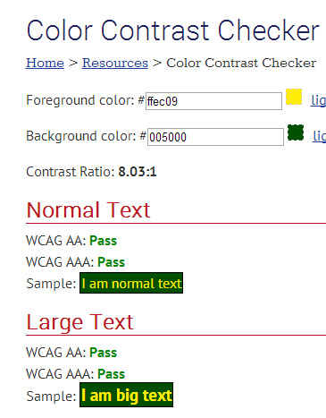 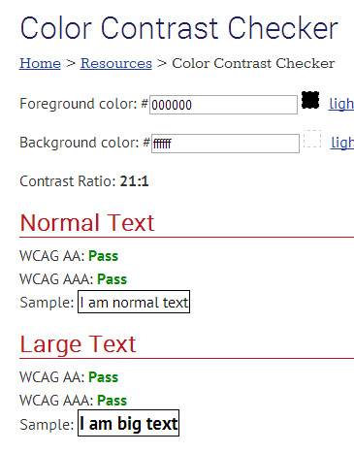

Dark side of the moon:
Heading v Background: Body text v Background: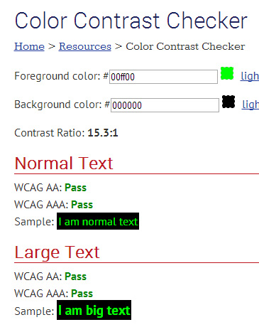 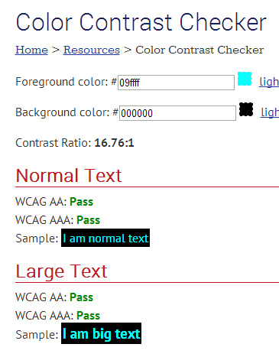

Standards:

The site will comply with the following standards:
- HTML
- CSS
Compliance will be tested by validation.

